Developing a College-Going Culture

Workbook
West Virginia Higher Education Policy Commission
Division of Student Affairs
(304) 558-0655

Assessment
Once you’ve reviewed the College-Going Culture Assessment tool, answer the following questions. Taking time to write down your thoughts and ideas will help you better understand your community’s needs. It can also lead to valuable insight that can guide you as you seek to make long-term, sustainable change.
- Which level most closely aligns with your school’s current environment?

- What are your strengths? What are your weaknesses?

- What factors do you think have caused you to be strong in certain areas? What factors have contributed to your weaknesses?

- How can you further leverage your strengths?

- What changes need to occur for you to overcome your weaknesses?

- Who can help you as you work to drive change? Who’s buy-in or influence will be critical? How can you get them involved and on-board?

Awareness
Building awareness for your cause is the first step toward driving cultural change on any issue. You can think of the Awareness stage as your opportunity to build the foundational understanding needed to engage your community.

Sphere of Influence
Let’s start by identifying “quick wins” or easy opportunities to make college opportunities more visible in your school community. Often, the best way to do this is to start with your own immediate sphere of influence and then expand outward.
Using the graphic organizer on the following page, identify
- Three ideas for how you can make college opportunities more visible in your immediate workspace or classroom. For example, you might decorate your door with college pennants.
- Two ideas for how you can use your network (your friends, departmental colleagues, or other individuals you work closely with) to help increase visibility. For example, you might recruit your entire department to start each class with a bit of college trivia.
- One idea for how you can increase visibility within the school building. For example, you might convince the administration to include college facts during each day’s announcements.

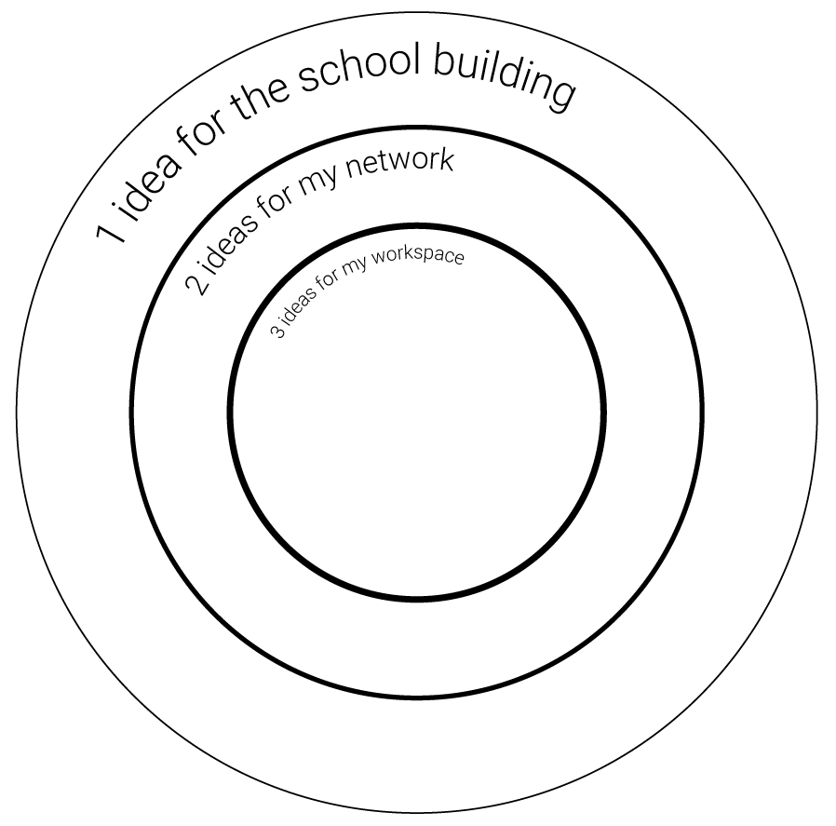

Mobilization
As you begin to recruit others to support and expand on your school’s efforts to build a college-going culture, it will be important to have a strategic plan to engage key stakeholders. One easy way to organize your thinking and formulate a strategy is to consider the “6 Basic Questions”: Who, What, Where, When, Why, How? Take some time to work through the questions and exercises below:

Who
Who does this issue affect? Who has to be involved for change to occur? Use the Audience Mapping Matrix that follows to identify and prioritize your key stakeholders.

Audience Mapping Matrix
How to use this tool: Identify the numerous stakeholders you need to influence to make change and build a stronger college-going culture. Then map them according to 1) the impact they are likely to have if you’re able to engage them as advocates and 2) the level of access you currently have to them.
For example, the Governor may be able to make a big impact by proposing policies to support college access. But you may have low access to him or her. If that is the case, you would place the Governor in the “high budget” quadrant. Conversely, getting students themselves on board is likely to make a big impact, and, if you work in a school, you likely have easy access to them. They would therefore fall into the “quick wins!” quadrant.

Prioritizing Audiences
- Quick wins: Focus your time and resources here first.
- Low budget: Do not devote significant time or resources to this group. Consider these audiences as folks who it would be “nice to have” on board.
- High budget: To reach this group, you will likely have to devote significant time, energy, and resources. However, your efforts are likely to pay off if you’re strategic. Before undertaking an effort to reach this audience, take the time to develop a comprehensive Strategic Communications Plan (link downloads an MS Word document).
- Last priority: As these people are hard to reach and likely will have less of an impact on your ultimate success, reaching them should be at the bottom of your list of priorities.
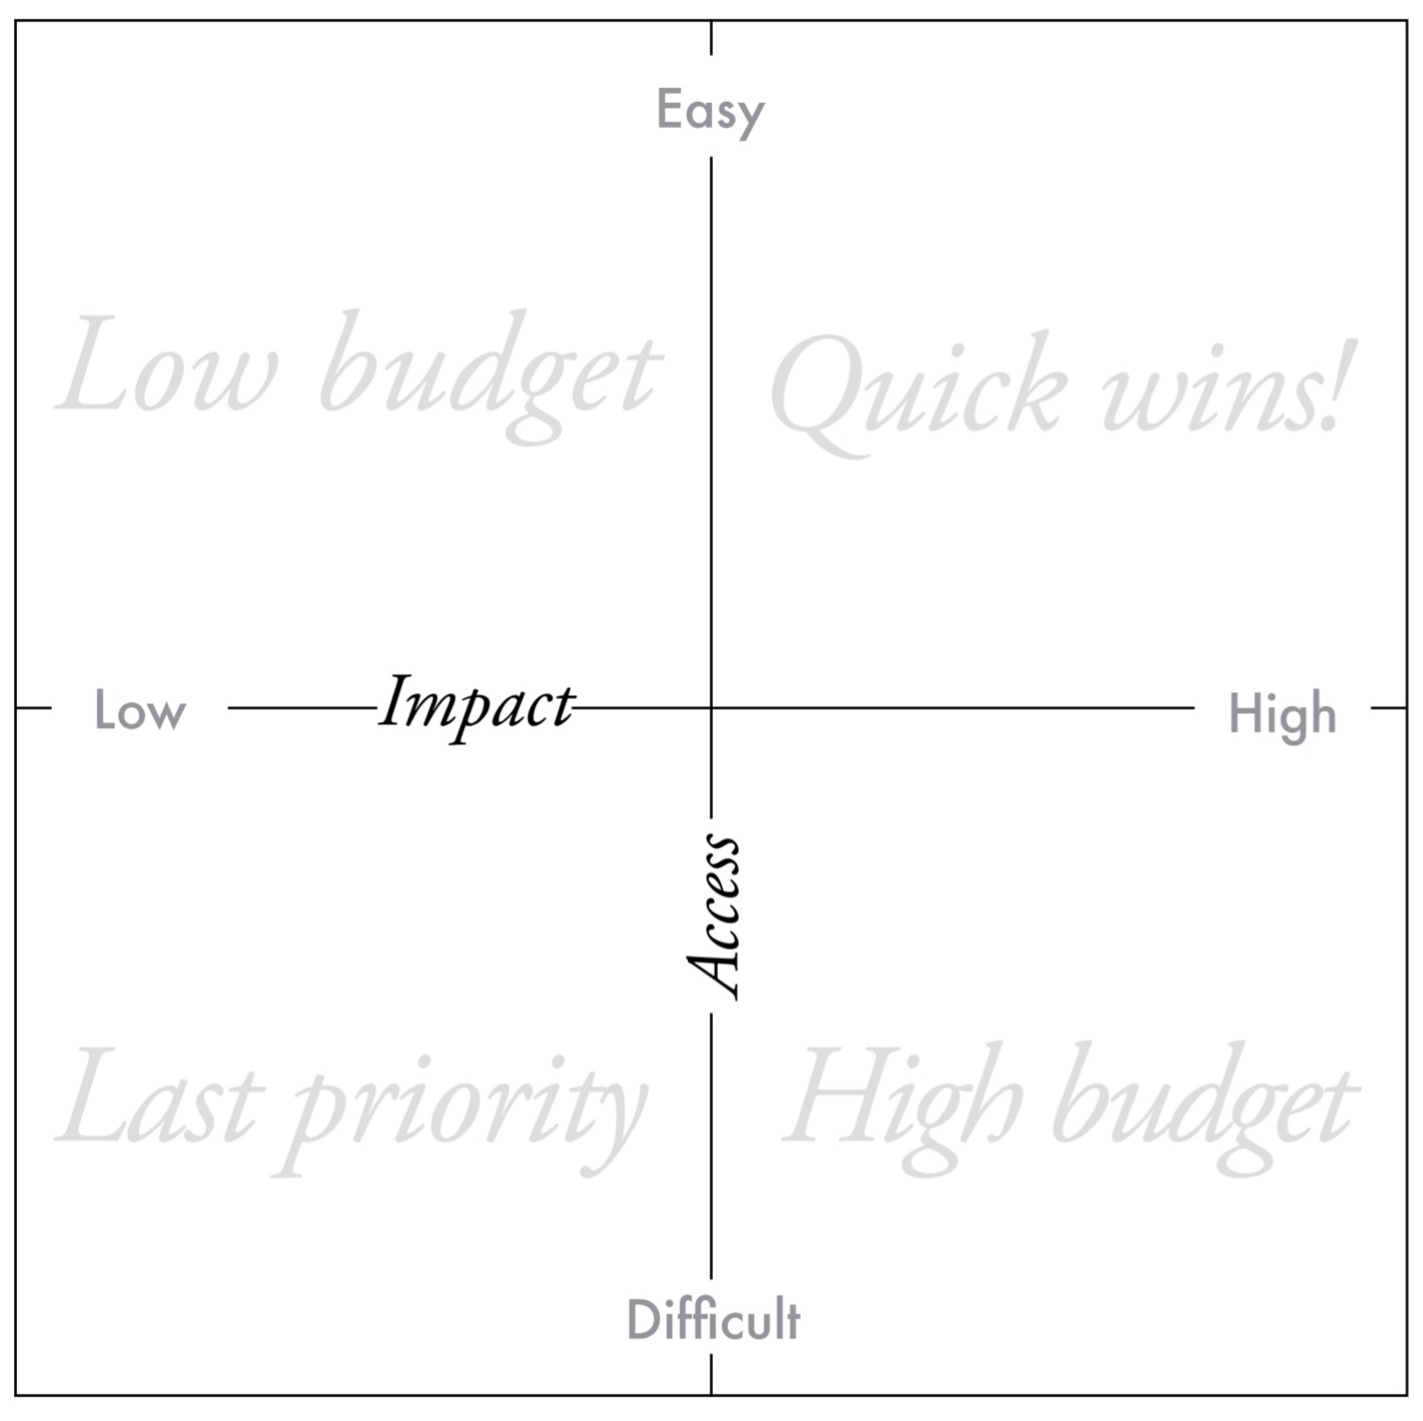

What
What are you trying to change or achieve? Start with a big-picture goal and work backward to set smaller goals and objectives to support it. Take a moment to watch this short video on setting goals, objectives, and KPIs. Then, work through the worksheet below to identify your overarching goal and three to five supporting objectives. .

Goal-Setting Worksheet
My overarching goal is:

Objective 1:
I will measure progress toward this objective by
- KPI 1
- KPI 2

Objective 2:
I will measure progress toward this objective by
- KPI 1
- KPI 2

Objective 3:
I will measure progress toward this objective by
- KPI 1
- KPI 2

Where
Rather than trying to convince your audiences to come to you, it can often be easier to meet them where they are. What are some places you can reach or connect with key audiences? List at least 10 ideas here:
- .
- .
- .
- .
- .
- .
- .
- .
- .
- .

When
When it comes to timing messaging and outreach, there are two factors: stage of development and personal context.

Stage of Development
Often when we consider aligning our messages and outreach according to stage of development, we think about students and their educational journeys. We know that the way you provide postsecondary counseling varies according to students’ age, grade level, and the time of year.
For example, you might stress the need to take rigorous courses and visit college campuses to freshmen and sophomores. While, for seniors, you would likely focus on specifics such as how and when to apply, how to secure financial aid, and how to complete the enrollment process.
But thinking about the stage of development for other audiences, such as colleagues we’re trying to recruit to help us build a college-going culture, may be less clear-cut. In this case, their stage of development depends on their understanding of the issue, their experience working within that space, and their level of buy-in. We cover these concepts in detail in the Mobilization and Collective Impact sections of this toolkit.

Activity:
Review the college-planning timelines listed below. Then jot down notes on ways you can improve the timing of your outreach or new activities you may want to add to your school’s outreach timeline.
- Road Map to College
- Senior Year Road Map
- Financial Aid Road Map

Personal Context
Timing your messages, outreach, and counseling according to the context your audience is experiencing in the moment is a critical factor for success. For example, many high school seniors are gathered in one place on prom night, but that doesn’t mean it’s a great opportunity to remind them of college enrollment deadlines. They simply aren’t in the headspace for something so serious during a night of celebration.
If your aim is to encourage action, take the time to think through what your audience will have to do to complete that action. What are the steps involved? What tools, references, or resources will they need? Can the action be completed any time? Anywhere? Is it time-limited? Or location-specific?
By answering these questions, you’ll develop a sense of context that can inform your messaging and program design. That way, you can deliver messages in a time and place that allows your audience to focus and act on them.
Additionally, we suggest utilizing “just in time” reminders. These reminders are messages that occur within a strategic contextual window: that sweet spot where the ability to act and the urgency to act overlap.
In other words, we want to give them enough time to be successful — we don’t want to remind students and parents of a financial aid application deadline 10 minutes before it’s due. But we don’t want to send the reminder so early that there’s no urgency.

Resource:
The CFWV Txt 4 Success program provides 12th grade students with “just in time” college-planning reminders via text messaging. You may want to consider encouraging your students to sign up for this service or setting aside time to help them sign up.

Why

Elevator Pitches
Have you ever heard of an elevator pitch? It’s called an elevator pitch because it’s a statement that boils down everything someone needs to know about your program, service, or cause into a :30 pitch that can be shared in roughly the length of an average elevator ride. The most effective elevator pitches share WHY people should care about your initiative.
Take a moment to write down your elevator pitch for your efforts to build a college-going culture. Keep it short and direct, and make sure it answers the following questions:
- What are you trying to accomplish?
- Who is it for?
- Why does it matter?

Activity:
Write your elevator pitch here: Insert

Positioning Statements
While it’s helpful for organizations to have an overarching elevator pitch that can be used for a broad audience, having pitches tailored to various stakeholders takes your communication to the next level. In marketing, these are often referred to as “positioning statements.” For example, a positioning statement aimed at students might focus on the opportunities for personal, career, and financial growth that a college education brings. While a positioning statement for a community partner may emphasize the societal and economic benefits of increasing higher education attainment rates in the region.
Here’s another example: Let’s say you’re focusing on a goal of increasing FAFSA completion rates. When writing a positioning statement for a student, you might focus on the amount of money available to help pay for college. But when writing a statement to encourage teachers at your school to support your FAFSA campaign, you may want to focus on how college-going rates are causally correlated with FAFSA-completion rates to show them how putting in this extra effort can help their students succeed.

Activity:
Identify two or more audiences you need to reach to achieve the goals you outlined earlier. For each audience, write a positioning statement. As with your elevator pitch, these should be succinct and clearly answer what you’re trying to do, who it’s for, and why they should care.
Audience 1: Insert
Positioning Statement: Insert
Audience 2: Insert
Positioning Statement: Insert

How
Once you’re clear on what you’re trying to accomplish and who it’s for, you can begin to build a plan for how you’re going to do it. One way to articulate how all the pieces fit together to form a comprehensive strategy is to develop a Theory of Change.

Theory of Change
A Theory of Change helps you connect what you’re doing to why you’re doing it. It also helps you determine if your efforts are working. It’s a framework that begins with the outcomes you’re trying to achieve and helps you work backward to design interventions to support your goals. Here’s an example:
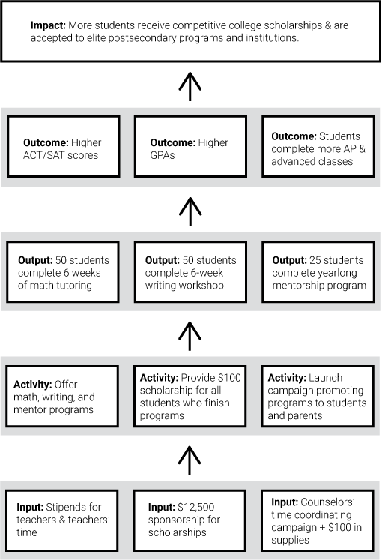

Activity
Develop your Theory of Change. Use the Goal, Objectives, and KPIs you identified earlier to complete the Impact, Outcomes, and Outputs sections.
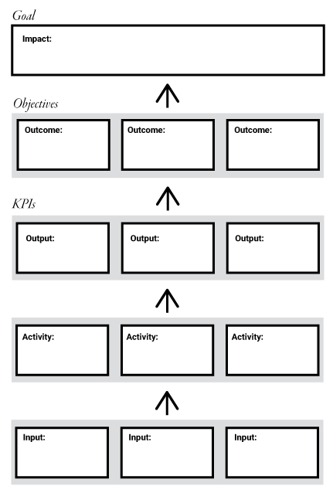

Collective Impact
At the Collective Impact stage of building a college-going culture, stakeholders, and organizations from across sectors and throughout the community must come together in a formalized way to support students’ educational attainment.
The activities below will help you think through some of the key considerations for creating a community wide, cross-sector organization focused on supporting a college-going culture.

Recruitment
One strategy for ensuring that your organization represents a holistic approach is to recruit organizations and individuals representing the 8 Dimensions of Wellness.
Use the space below to brainstorm potential recruits from each area.

A Holistic Approach

Emotional/Mental
1.
2.
3.

Financial
1.
2.
3.

Environmental
1.
2.
3.

Intellectual
1.
2.
3.

Social
1.
2.
3.

Occupational
1.
2.
3.

Physical
1.
2.
3.

Spiritual
1.
2.
3.

Articulating Your “Why”
What the video How Great Leaders Inspire Action to learn about the Golden Circle and “Starting with Why.” Then complete your own Golden Circle below.
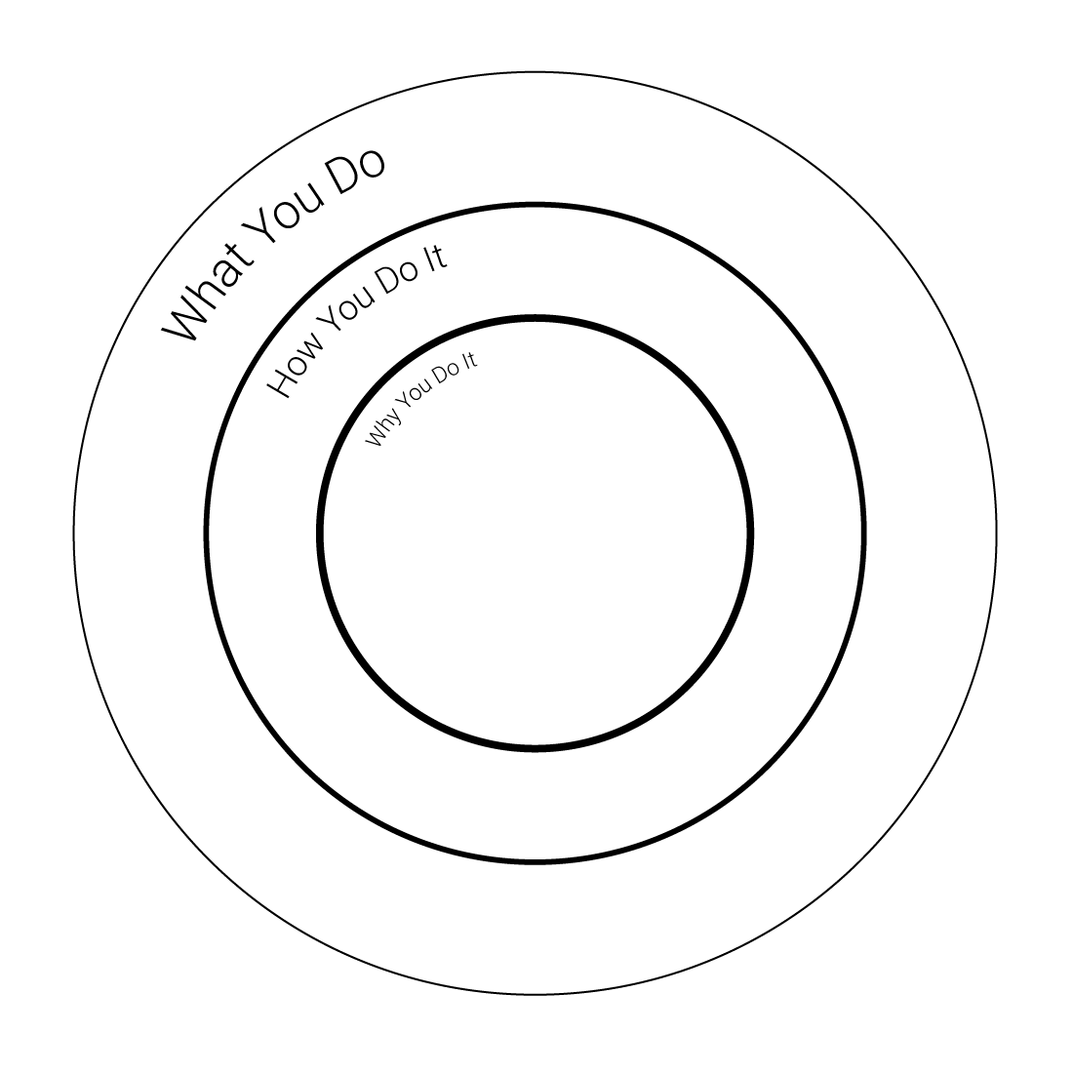

Now that you’ve jotted down some initial thoughts, take some time to reflect on why supporting the educational attainment of students is important to you, personally. Write it down in the space below. If you can communicate your own passion for this effort, it will be easier for you to engage and inspire others.

Vision Setting
One of the most important factors in developing a successful college attainment organization is being able to find clarity and consensus around your shared goals and objectives. As we noted in the toolkit, we recommend adopting no more than one overarching goal and no more than five supporting objectives.

Activity
If you’re having trouble narrowing your focus, try this exercise: Look at the problem you’re trying to address. Then ask “why” the problem exists. But don’t stop there. Keep asking “why” until you get to the heart of the problem. For example:
Problem: Students who are eligible for financial aid aren’t taking advantage of it.
Why? Because they aren’t completing the FAFSA.
Why? Because they don’t understand it’s importance and they think it’s too complicated.
Why? Because they aren’t informed about the importance and the fact that it’s gotten much easier.
Why? Because they aren’t paying attention to our FAFSA messaging.
Why? Because it comes from their high school counselors and they don’t have strong relationships with them.
Why? Because our high school counselors are overloaded with administrative duties and don’t have time to focus on counseling.
There’s the heart of your problem. How can you help get your counselors back to providing counseling?
Now it’s your turn. Identify a problem below and keep asking why until you get to the bottom of it. For most people, it takes at least five “whys” to gain clarity.
Problem:
Why?
Why?
Why?
Why?
Why?

Sustained Innovation

Aligning Resources
Once your college attainment organization has developed clarity around a common vision and shared goals, you’ll need to ensure that resources are aligned to support them. This could mean seeking new funding through grants or donations. Or it could mean reallocating existing resources. It likely comes as no surprise that the latter can cause controversy, so you’ll want to be thoughtful and sensitive if you go this route. One strategy is to undertake asset mapping.
The template below offers you space to brainstorm existing assets you might make use of as you work to support college attainment in your community.

Asset Map
For each category below, list some assets your community or network possesses.
Physical Assets: land, buildings, infrastructure, and facilities

Economic Assets: products, goods, and services as well as major employers; financial sources such as private donors, philanthropic organizations, or public budgets or funds

Stories, Traditions, and Symbols: cultural touchstones or histories that may help you connect with or engage the community you serve

Residents and Community Members: Individuals with skills, expertise, or interests that can support your work

Social Groups: Faith-based organizations, athletic clubs, or hobby groups

Institutions: public organizations such as schools, libraries, or park or nonprofit organizations

Fueling Research, Creativity, and Debate
Sustaining your work and developing an environment that supports continual improvement is the ultimate goal of anyone seeking to create cultural change. But, reaching this stage doesn’t mean your work is done. As we said earlier in this toolkit, building a college-going culture isn’t a task you can “check off” your to-do list.
The very definitions of sustainability and continual improvement indicate that this work is never ending. And one of the more exciting things about working in the education and community development space is that the opportunities for innovation are limitless. We can always make things better.
At this point in your journey, your job is to continue finding ways to grow, learn and improve. So, for our final workbook activity, we encourage you to choose one of the books below to read. Then, jot down your thoughts and reflections here.

Books on Organizational Culture and Innovation:
- Good to Great by Jim Collins
- The Culture Code by Daniel Coyle
- Leadership Without Easy Answers by Ronald Heifetz
- The Fearless Organization by Amy Edmondson
- Leading Continuous Change: Navigating Churn in the Real World by Bill Pasmore
The book I chose was:
Reflections:

West Virginia Higher Education Policy Commission
Division of Student Affairs
(304) 558-0655

